

November 4th, 2023



**GROUP11 CREAT1VE 1NNOVATORS**

**Robotic Garbage Car**

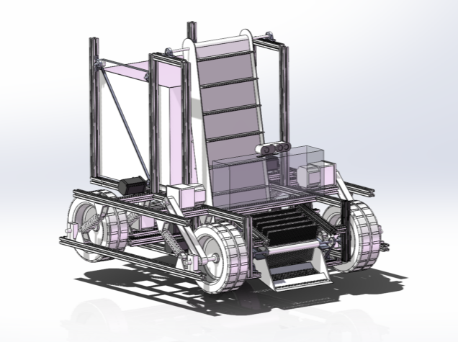

**Group members:**

Wenjun Cheng

Lianjie Yuan

Chenming Ge

Chengyuan Wang

Table of Contents

I. Abstract 3

II. Introduction 4

III. Problem 5

IV. Needs 5

V. Solution… [Project Name] 6

VI. Objectives 7

VII. Tasks 7

VIII. Schedule 10

IX. Budget 10

X. Key Personnel 11

XI. References 11

XII. Appendix 12

# Abstract

While most people on the campus have a strong awareness of environmental protection, the phenomenon of littering still cannot be completely avoided due to various reasons. Garbages, mainly consisting of beverage bottles, can often be seen on the sidewalks throughout the campus. The major solution currently for the problem is manual collection, which is hardly efficient. Our project aims at creating an robotic garbage-collecting car that is able to automatically clean the rubbish on the sidewalks. We plan to employ vision-based system for the garbage detection and obstacle avoidance function. We will also design a temporary garbage storage which can transfer the collected garbage into the bin at appropriate time. The completed product will be able to maneuver on the sidewalks by its 4-wheel drive, automatically collecting the detected garbage. It will stop at the crossroads and judge the road condition to avoid disturbing the traffic. The robotic car will be functional and safe, improving the campus environment while reducing the labor cost.

# Introduction

Our team, consisting of four members - Wenjun Cheng, Lianjie Yuan, Chenming Ge, and Chengyuan Wang, was founded with a shared objective: to innovate products that enhance people's lives. Through careful observation of our daily lives, we identified a pressing need for an automatic garbage collecting car that could address the significant challenges faced by urban environments. In response to this need, we have embarked on a mission to design a more compact and efficient structure for garbage collection, leveraging the advancements in neural network technology. Our ultimate goal is to contribute to a cleaner and more sustainable environment.

By focusing on the development of an intelligent urban street sidewalks cleaning vehicle, we aim to revolutionize waste management practices within university campuses and beyond. With our expertise and dedication, we seek to overcome the limitations of traditional waste collection methods by implementing a system that is more intelligent and automatic, enabling the vehicle to effectively collect and sort different types of waste. We believe that our innovative solution has the potential to not only improve cleanliness and waste management within the campus environment but also serve as a model for broader communities, promoting sustainable waste management practices and creating a positive social and environmental impact.

# Problem

The increasing number of vending machines and beverage shops on campuses has greatly facilitated teachers and students, while it has also exacerbated a serious problem: littering. Although most college students have a strong awareness of environmental protection, the phenomenon of littering cannot be completely avoided.

It is straightforward to understand why the problem of littering is so severe and hard to be completely solved. On one hand, not everyone has a high level of moral standards, even in the high-level institute like SJTU. On the other hand, the reduction in the number of trash bins due to waste sorting policies has also decreased people's willingness to carry trash to designated disposal areas. Moreover, accidental littering is also unavoidable.

While everything seems to have something to do with automation in today’s world, garbage, one of the biggest challenges facing the urban street environment, hasn’t yet attained its automated solution. Currently on the campus, the garbage on the sidewalks are mainly collected by sanitation workers, resulting in low efficiency.

Indeed, there are already many solutions being implemented to address similar issues related to garbage and littering. The indoor automatic sweeping robots as well as the road cleaning vehicles have been well developed and mutual enough, whereas, a consummate product featuring automatic pedestrian cleaning haven’t emerged. Automatic sweeping robots have been widely used in indoor environments due to their high convenience and reliability. However, they are primarily designed for small waste like dust and have poor obstacle-maneuvering capabilities, making them unsuitable for outdoor sidewalk scenarios. Existing garbage trucks, on the other hand are mainly designed for vehicle lanes and cannot accurately identify and clean up trash like beverage bottles on sidewalks, and their automation level is relatively poor.

The problem of littering on campus sidewalks has many negative impacts. Firstly, trash like beverage bottles on sidewalks poses huge safety hazard to pedestrians. There have been many incidents of people slipping and getting injured due to stepping on trash, not to mention the numerous cyclists who use these sidewalks, which exist commonly on the campus. Moreover, if the trash is not promptly cleared, the continuous accumulation of garbage on the sidewalks can greatly damage the campus environment, leading to a deterioration of the overall image of the school. The existing manual solutions, whereas, are too inefficient and also lead to increased labor costs for the school. Therefore, there is an urgent need to develop an efficient and highly automated street garbage cleaning tool.  
 In fact, the issue of littering is not confined to schools but is a common challenge faced by the entire society and cities. This problem is even more significant and challenging outside of campuses. In the arduous task of building civilized cities and improving urban living environments, tackling the problem of littering is one of the most formidable challenges. Therefore, the development of automated and intelligent street garbage cleaning tools should not only serve campuses but also extend beyond them to address a broader range of issues. This approach would contribute significantly to enhancing urban cleanliness and promoting a more responsible and environmentally conscious society.

**In summary, while people’s moral quality has been greatly improved, littering phenomenon on the sidewalks cannot be solved decently. Problem exists, including:**

1. **Many people are unwilling to carry garbage to the rubbish bin.**
2. **Accidental littering cannot be completely avoided.**
3. **Manual cleaning is too inefficient and arouse high labor cost.**
4. **Current robotic sweeping machines aim at cleaning small rubbish such like dust, and have low maneuvering ability.**
5. **Rubbish trucks are too big and inaccurate for sidewalks, and have poor level of automation**

# Needs

Because of the contradiction between student enrollment expansion and insufficient dormitory, some of dorms are narrow in some Chinese universities, while a disorderly and unclean environment causes the narrowing of the pathways within the dormitory worse. Hence, there is a need for a more compact garbage collection system to address the challenges posed by the limited space and to maintain cleanliness.

As mentioned in the following paragraphs, there is a shortage of time for college students to collect rubbish, which means that college students won’t spend much time thinking about rubbish collection. This has prompted a demand for easier garbage collection systems so that college students won’t spend more time on the trivial thing.

University dorms generate various types of solid waste, including recyclables, organic waste, and general waste. An easy-to-use waste collection system capable of handling different types of garbage is necessary to address the specific waste diversity present in university dorms.

Because of lack of alternative ways to collect and sort waste, there still exists a need for creative or alternative approaches to gathering waste beyond conventional means, possibly exploring technological solutions or unconventional methods. Also, There's a requirement for improved methods of sorting waste, indicating a desire for alternatives that are more effective, environmentally friendly, or resource-efficient.

**In short, to solve these problems in rubbish collection and classification, several new tools are required including:**

1. **a more compact garbage collection system**
2. **Automatic machine that can collect and sort DSW**
3. **Easy systems that can collect different types of garbage in different modes**
4. **Alternative ways to collect and sort waste**

# Solution… [Project Name]

We have designed an intelligent dormitory garbage cleaning vehicle with precise calculation analysis and proposed verification. The project includes:

1. Detailed modeling of the main structure of the car

2. Accurate identification of ground waste

3. Cleaning of ground waste (using cans as an example)

The proposed dormitory garbage cleaning vehicle is shown in Figure 1. It consists of six parts: caterpillar, Garbage collection box, Track bracket, baffle, Storage box, Chassis, and wheels. The Garbage collection box includes a garbage recognition camera, as shown in Figures 2 and 3.



Figure 1: Modeling of Dormitory Garbage Cleaning Vehicle 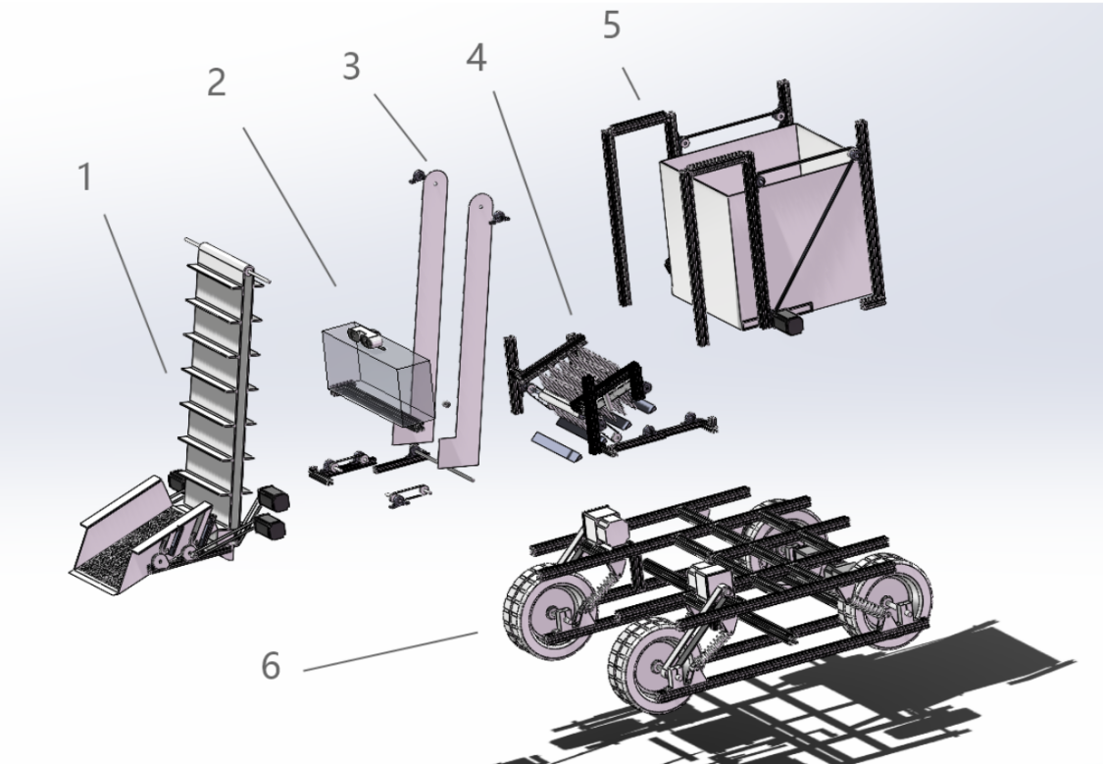

Figure 2: Modeling diagram of various components of dormitory garbage cleaning vehicle

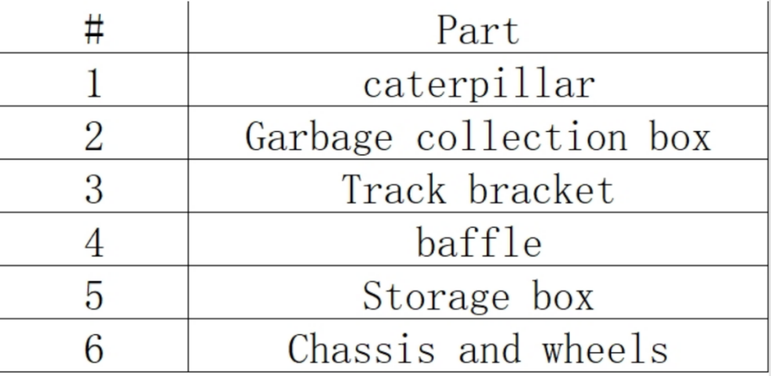

Figure 3: Table of Components of Dormitory Garbage Cleaning Vehicle

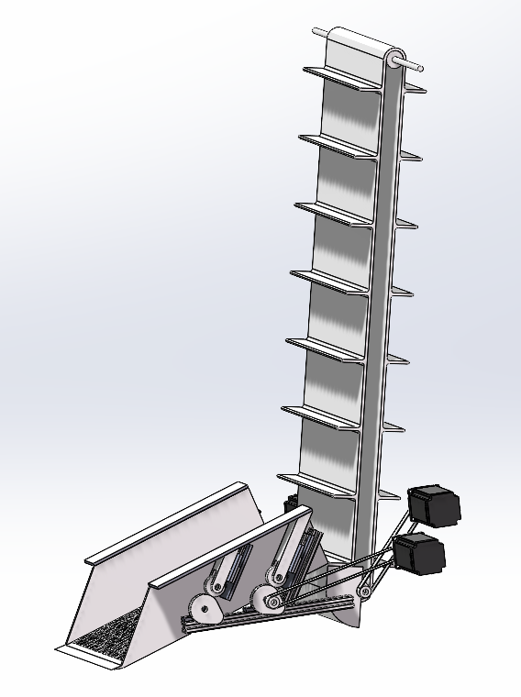

1. Caterpillar

Its function is to receive garbage and transport it to the garbage basket behind the car through tracks.

The material of the track is carbon fiber cloth, and all other materials are 3D printed.

Among them, we use two stepper motors to provide power to the track. In order to save electricity, the track will not rotate continuously. We install an ultrasonic sensor on one side of the track, and whenever we detect garbage entering, we will activate the track to rotate clockwise and transport the garbage to the trash basket. After transportation, rotate counterclockwise to return the track to its original position.

We have decided to reduce the partition to one, reducing its volume without changing its original function. However, this also allows the tracks to transport only one piece of garbage at a time, which we have addressed in other components.

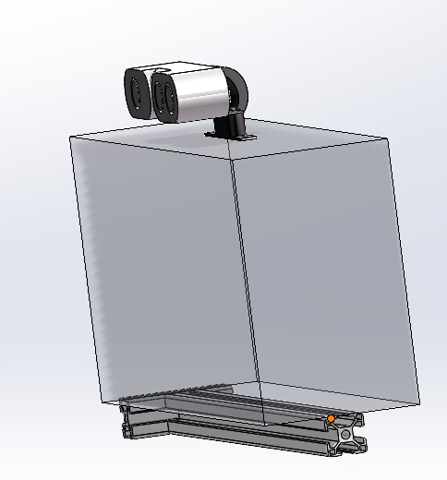

1. Garbage collection box

Its function is to store excessive waste, as the track can only transport one piece of waste at a time.

Its material is acrylic board, transparent, allowing for the observation of any excess waste inside. It is equipped with a camera to detect and identify garbage.

We have adopted the camera kit from the K210 development board, which can more accurately distinguish garbage through color differences.

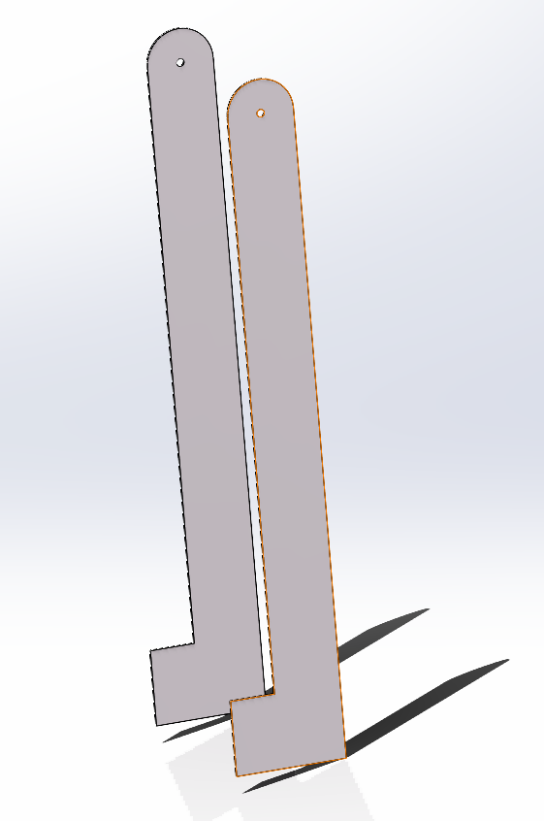

4.Baffle

Its function is to transport garbage from the ground to the baffle of the track.

Its material is 3D printing.

We have decided to change the track type to an excavation type, imitating excavators to pick up garbage from the ground and deliver it to the tracks. We use a stepper motor to provide power for excavation. This reduces the volume without changing the original functionality.

3.Track bracket

Its function is to fix the track and serve as a support for various parts.

Its material is 3D printing.

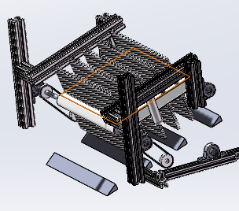

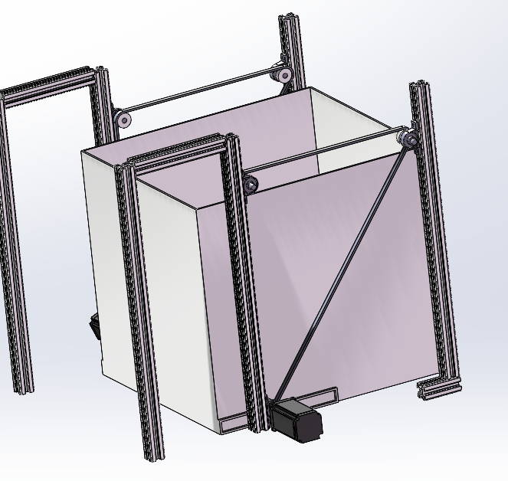

5.Storage box

Its function is a garbage receiver, collecting garbage.

Its material is acrylic board, and the bracket is 3D printed.

We plan to put on a garbage bag so that when all the garbage is collected, it can be directly packed and taken away.

We have decided to give up the function of garbage dumping, considering the height of the garbage bin, it is better to directly make it a garbage bin.

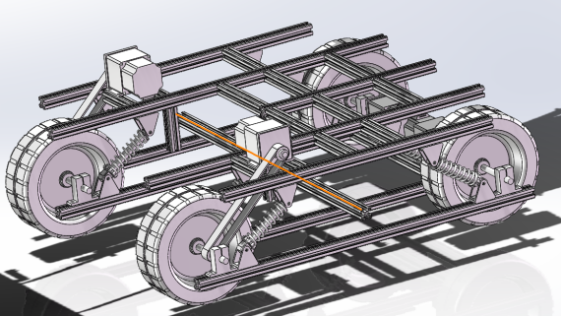

6.Chassis and wheels

Its function is to support the overall structure of the car and drive the car.

The wheels and motors are made of the same materials as Project 1, while the chassis is 3D printed.

The hollow chassis structure can reduce weight

# Objectives

Objective 1: Compact Garbage Collection System Development:

Design and implement a more compact and efficient garbage collection system that minimizes space requirements and optimizes waste storage. This system should be easily deployable in university dormitorys with limited space.

Objective 2: Design an Automatic DSW Sorting Machine:

Engineer an automated machine capable of efficiently collecting and sorting Dry Solid Waste (DSW) materials. This machine should incorporate advanced sensors and sorting mechanisms to accurately classify different types of waste, enhancing the overall efficiency of the recycling process.

Objective 3: develop versatile Garbage Collection Systems:

Develop versatile garbage collection systems that can adapt to different types of waste and collection scenarios. These systems should be easily configurable to collect specific types of waste in various modes, such as bulk collection for larger items and precision collection for smaller, segregated items.

Objective 4: Integration of Smart Technologies for Waste Management:

Integrate smart technologies such as Internet of Things (IoT) devices and data analytics into waste management systems. Develop systems that can monitor and manage waste collection routes dynamically based on real-time data, optimizing collection schedules and routes for maximum efficiency.

# Tasks

1. Purchasing Materials

In this process, we need to identify and procure necessary components for the robotic cars. The singlechip casting the role of the processing unit shall be decided, and we need to research and select appropriate sensors, motors, cameras that meet the demand. Besides these functional components, we will mainly employ 3D printing for the structural materials

1. Designing the Prototype

In this process, we need to design a prototype of the robotic cars. The prototype should be space-efficient and structural strong. Solidworks may be applied to develop the CAD models of the robotic cars. The layout of electrical circuits and sensors and camera placements shall as well be arranged. During the designing process, actual application scenarios need to be considered so that the products can be as practical as possible.

1. Assembling Components

In the process, the functional components will be integrated onto the main structure. Major tasks include assembling motors and wheels, installing cameras and sensors and connecting wires. The manuevering ability and structural strength of the car need to be considered.

1. Applying the OpenCV Graphic Model

In this process, we need to integrate and configure the OpenCV graphic model for the robotic car. As the car shall be able to judge the shape and color of different garbage, basic function including grayscale, color recognition, contour detection need to be applied. Calibration shall as well be configured on the cameras. Besides the basic functions, we are planning to employ gesture identification enabling the car to better respond to users’ requests.

1. Revising the Obstacle Avoidance Program

As the fundamental obstacle avoidance function has been realized in phase one, it need to be modified and revised in order to fit the application scenario. As it is mainly applied in the dormitory, the speed may be sacrificed for improvement in mobility. The ability to prevent and recover from dilemma also need to be enhanced.

6. Testing and Improving the Prototype

In this process, the prototype of the robotic car need to be tested in real life dormitory scenario for data collection and problem searching. After the test, the prototype will be modified and improved.

1. Preparing Materials for Design Expo

Materials such as demonstration setup (bottles, bags etc in different shape and color), Multimedia presentation and posters need to be designed and prepared in order to make the design expo more attractive and informative.

1. Writing Reports

A report is necessary for documenting the development process and results. We will compile a comprehensive report detailing the design, project process and testing results as well as the robot’s performance and restriction desiring for future improvement.

1. Participating in Design Expo

# Schedule

The schedule of the project will be demonstrated in the Gantt Chart below:

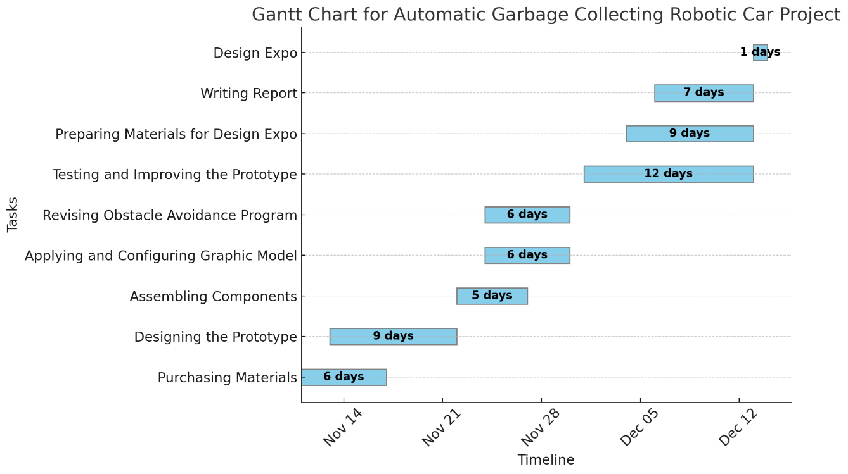

# Budget

|  |  |  |
| --- | --- | --- |
|  | Description of Work | Anticipated Costs |
| Task 1 | Trash bin | 1.00 |
| Task 2 | 3D-print body of the robot | 16.00 |
| Task 3 | Arduino Uno board | 10.00 |
| Task 4 | Ultrasonic sensor | 0.20 |
| **Task 5** | Maixduino demo board | 33.50 |
| **Task 6** | stepping motor | 5.00 |
| **Task 7** | DC motor | 1.00 |
| **Task 8** | crawler belt | 5.00 |
|  | Total | $ 71.70 |

# Key Personnel

Team leader:

Chenming Ge:

Principle role: programming

Team members:

Wenjun Cheng:

Principle role: hardware assembly

Lianjie Yuan：

Principle role: designing

Chengyuan Wang:

Principle role: testing & communication

# Reference

[1] Y. Pan, M. Li, H. Guo, Y. Li, and J. Han, “Influencing factors and reduction of domestic solid waste at university dormitory in Shanghai, China,” Sci Rep, vol. 12, no. 1, p. 570, Jan. 2022, doi: 10.1038/s41598-021-04582-0.

[2] F. Simpeh and W. Shakantu, “An on-campus university student accommodation model,” JFM, vol. 18, no. 3, pp. 213–229, Jul. 2020, doi: 10.1108/JFM-03-2020-0017.

[3] H. Zhang, J. Liu, Z. Wen, and Y.-X. Chen, “College students’ municipal solid waste source separation behavior and its influential factors: A case study in Beijing, China,” Journal of Cleaner Production, vol. 164, pp. 444–454, Oct. 2017, doi: 10.1016/j.jclepro.2017.06.224.

[4] M.-H. Zhou, S.-L. Shen, Y.-S. Xu, and A.-N. Zhou, “New Policy and Implementation of Municipal Solid Waste Classification in Shanghai, China,” IJERPH, vol. 16, no. 17, p. 3099, Aug. 2019, doi: 10.3390/ijerph16173099.

[5] T. C. Kelly, I. G. Mason, M. W. Leiss, and S. Ganesh, “University community responses to on-campus resource recycling,” Resources, Conservation and Recycling, vol. 47, no. 1, pp. 42–55, May 2006, doi: 10.1016/j.resconrec.2005.10.002.

# Appendix

[Provide supporting material for your proposal here. Only supporting material may be placed here; vital information belongs in the main part of the proposal.]